Using Traveling Salesman Problem Algorithms for Evolutionary Tree Construction
Chantal Korostensky and Gaston H. Gonnet
Institute for Scientific Computing ETH Zurich, Switzerland
Abstract
We present a new tree construction method that constructs a tree with maximum probability for a given set of sequences. The problem of tree construction is reduced to the Traveling Salesman Problem (TSP).
- Introduction
- Methods
  - Scoring of Pairwise Alignments

- Probability of an Evolutionary Configuration
  - Sum of Pairs versus Circular Sum measure
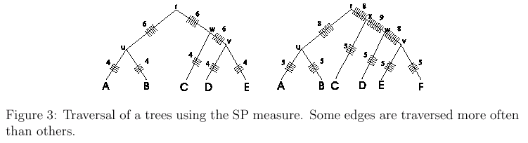
  - Traveling Salesman
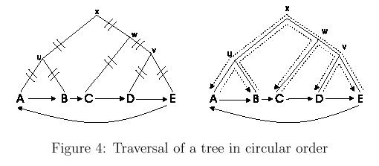
  - Scoring an Evolutionary Tree
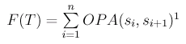
  - Finding a circular order
- Error Bound
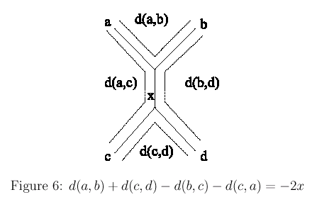
- Tree Construction Algorithm
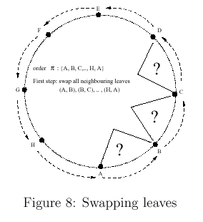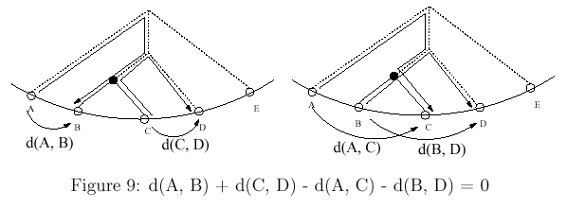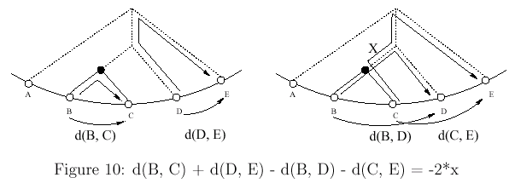
- Example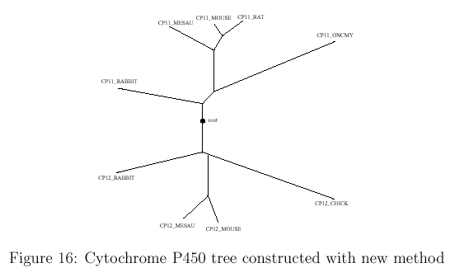
Created by: Chia-Mao Huang
Date: Sep. 14, 2000

